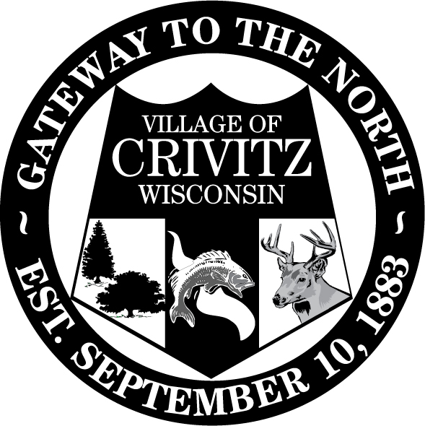
Village of Crivitz Phone (715)854-2030
800 Henriette Ave. Fax (715)854-2748

P.O. Box 727 e-mail: emoser@crivitz.gov

Crivitz, WI 54114

Visit us on the web at www.villageofcrivitz.com
*************************************************************************************
NOTICE of AD HOC COMMITTEE MEETING

Notice is hereby given that the LITTLELAND PLAYGROUND COMMITTEE and ad hoc committee formed by the Village of Crivitz Board of Trustees will hold a meeting on Tuesday, April 8, 2025, beginning at 4:30pm in the boardroom of the Crivitz Village Hall located at 800 Henriette Ave., Crivitz, WI. This meeting will be held in person. Meeting materials may be obtained by contacting the Crivitz Village Clerk by email or at the phone number above. Although no action will be taken at this meeting, the public is hereby notified that a quorum of the Crivitz Village Board may be present.

LITTLELAND PLAYGROUND COMMITTEE
Playground
Design
Fundraising
Other

Please note that, upon reasonable notice at least 24 hours in advance, efforts will be made to accommodate the needs of disabled individuals through appropriate aids and services. For additional information to request this service, please contact the Village Clerk's Office at (715)854-2030, 800 Henriette Ave., P.O. Box 727, Crivitz, WI 54114.

Dated this 7th day of April 2025
Elizabeth Moser, Clerk/Treasurer

